AWS ELASTIC COMPUTE CLOUD (EC2)
Agenda
- Introduction
- Importance of Amazon EC2
- Key Characteristics of Amazon EC2
- Advantages of Amazon EC2
- Disadvantages of Amazon EC2
- AWS EC2 instance types
- AWS EBS
- Security Group
- AWS Machine Image
- Elastic IP
- Creation of EC2 Instance
Introduction:
Amazon Elastic Compute Cloud (Amazon EC2) is a web service that provides secure, resizable compute capacity in the cloud. It is designed to make web-scale cloud computing easier for developers by offering virtual servers (instances) for hosting applications, websites, or backend systems.
Importance of Amazon EC2:
- Foundation for Cloud-Based Applications:
  - EC2 serves as the backbone for hosting and running applications in the AWS cloud.
  - Enables users to launch instances of various configurations to meet specific computing requirements.
- Scalability:
  - Provides the ability to dynamically scale resources up or down based on demand, ensuring optimal performance and cost-efficiency.
- Versatile Use Cases:
  - Ideal for running web servers, backend servers, databases, and even large-scale distributed systems.
  - Can be used for development, testing, and production workloads.
- Global Reach:
  - Allows deployment across multiple geographic regions for improved latency and redundancy.
Key Characteristics of Amazon EC2:
Amazon EC2 (Elastic Compute Cloud) provides a robust and scalable infrastructure for hosting and running applications in the AWS cloud. Below is an overview of its key features:
1. Elasticity and Scalability
- Dynamic Resource Scaling:EC2 enables users to scale compute resources up or down based on demand. This ensures applications run efficiently during traffic spikes or quiet periods.
- Auto Scaling Integration:Automatically adjusts the number of instances based on defined conditions, maintaining performance while minimizing costs.
2. Wide Variety of Instance Types
- Optimized for Workloads:EC2 offers various instance types tailored to specific workloads:
  - General Purpose: Balanced resources (e.g., T3, M5 instances).
  - Compute Optimized: High CPU performance for tasks like data analytics (e.g., C5 instances).
  - Memory Optimized: High memory for large datasets and in-memory databases (e.g., R5 instances).
  - Storage Optimized: High-speed storage for I/O-intensive tasks (e.g., I3 instances).
  - Accelerated Computing: GPU-based instances for machine learning and graphics workloads (e.g., P4 instances).
3. Flexible Pricing Models
- On-Demand Instances:Pay only for what you use, with no long-term commitments. Ideal for short-term and unpredictable workloads.
- Reserved Instances:Commit to a one- or three-year term for lower costs, suitable for steady workloads.
- Spot Instances:Utilize unused capacity at discounted rates, perfect for fault-tolerant and flexible applications.
4. Secure Networking
- Virtual Private Cloud (VPC):Each EC2 instance runs within a logically isolated network for enhanced security and control.
- Security Groups and NACLs:Firewalls at both instance and subnet levels to manage inbound and outbound traffic.
5. Customizable Configurations
- Choice of Operating System:Select from Linux distributions (Ubuntu, Red Hat, Amazon Linux) or Windows Server versions.
- Amazon Machine Images (AMIs):Use pre-configured templates to launch instances quickly or create custom AMIs tailored to your needs.
6. High Availability and Reliability
- Regions and Availability Zones (AZs):Deploy instances across multiple AZs to ensure fault tolerance and high availability.
- Elastic Load Balancing (ELB):Automatically distributes incoming traffic across multiple instances to prevent overloading.
7. Integrated Monitoring and Management
- AWS Systems Manager:Automate operational tasks, such as software patching, inventory collection, and resource management.
- Elastic Beanstalk:Simplify deployment and management of applications without manual configuration.
8. Storage Options
- Amazon Elastic Block Store (EBS):Persistent storage volumes for EC2 instances, offering features like snapshots and encryption.
- Amazon Elastic File System (EFS):Shared file storage for applications requiring concurrent access.
9. Global Deployment
- Geographic Reach:Launch EC2 instances in various AWS Regions worldwide, minimizing latency and adhering to data compliance.
- Edge Locations:Leverage AWS’s global network to serve content with reduced latency.
10. Integration with Other AWS Services
- Seamless Connectivity:EC2 integrates with S3 for storage, RDS for managed databases, and Lambda for serverless applications.
- IAM Roles:Assign roles to EC2 instances for secure access to AWS resources without hardcoding credentials.
Advantages of Amazon EC2:
1. Flexibility
- Choice of Operating Systems:Users can select from a wide range of operating systems, including Linux distributions (Ubuntu, Red Hat, Amazon Linux) and Windows Server. This flexibility allows compatibility with various application requirements.
- Customizable Instance Types:EC2 offers diverse instance types to meet specific computing needs, from general-purpose workloads to compute-intensive and memory-intensive applications.
2. Scalable Infrastructure:
- Dynamic Scaling:Automatically scale up or down based on traffic or demand using Auto Scaling. This ensures efficient resource utilization without manual intervention.
- Elastic Load Balancing:Distribute traffic across multiple instances to maintain performance and ensure high availability.
3. Reliability:
- AWS Global Infrastructure:EC2 instances are hosted in data centers with redundancy and fault-tolerance to ensure high uptime.
- Service-Level Agreement (SLA):AWS guarantees 99.99% availability for each EC2 Region, providing confidence in the platform’s stability.
4. Security:
- Integrated Security Features:Amazon EC2 is tightly integrated with AWS Identity and Access Management (IAM) to control access to resources securely.
- Network Isolation:Use Virtual Private Cloud (VPC) to create isolated networks for EC2 instances. Security Groups and Network Access Control Lists (NACLs) further enhance instance-level protection.
5. Cost Efficiency:
- No Upfront Costs:Avoid significant capital expenditures for hardware. EC2 provides an on-demand model where you only pay for the resources you use.
- Multiple Pricing Options:Reduce costs with Reserved Instances, Savings Plans, or Spot Instances for flexible workloads.
Disadvantages of Amazon EC2:
1. Complexity:
- Steep Learning Curve:Managing EC2 instances, configuring networks, and optimizing costs can be complex, especially for beginners.
- Operational Overhead:While EC2 offers flexibility, it also requires users to handle OS updates, patching, and system maintenance unless using managed services.
2. Costs:
- Potential for High Costs:Without proper monitoring, costs can escalate, especially with on-demand instances or data transfer charges between regions.
- Hidden Costs:Additional costs for associated services like EBS storage, data transfer, and Elastic IPs can be significant.
3. Security Management:
- User Responsibility:While AWS secures the underlying infrastructure, users are responsible for securing their instances, including setting up firewalls, managing access keys, and ensuring data protection.
- Misconfigurations:Improper configurations in security groups or IAM roles can expose systems to vulnerabilities.
4. Downtime Risks:
- Regional Outages:Despite high reliability, rare outages in a specific AWS region can disrupt applications if they are not architected for multi-region redundancy.
5. Resource Management Challenges:
- Scalability Limits:Though scalable, poorly designed applications may still face bottlenecks. Auto Scaling requires careful configuration to function effectively.
- Storage Limits:Default storage limits may need to be increased manually for applications with high data requirements.
6. Dependency on AWS Ecosystem:
- Vendor Lock-In:Once applications are heavily reliant on EC2 and other AWS services, migrating to another cloud provider can be challenging and costly.
Real-World Use Cases of Amazon EC2:
1. Web Hosting
- Hosting Dynamic Websites:EC2 instances can be configured to host websites, offering the ability to scale resources based on traffic patterns. For example:
  - Use a load balancer to distribute incoming requests across multiple EC2 instances.
  - Store static content like images and videos in S3, reducing server load.
2. Big Data Processing
- Data Analysis at Scale:EC2 is frequently used for processing large datasets in real-time or batch modes. For instance:
  - Launch compute-optimized instances for processing logs, transaction data, or IoT data streams.
  - Integrate with services like Amazon EMR (Elastic MapReduce) to run Hadoop and Spark jobs efficiently.
3. Machine Learning Workloads
- Training and Inference:Machine learning models often require GPU-enabled instances for faster training and inference:
  - Use Accelerated Computing Instances (e.g., P4, G5) for training large AI models.
  - Scale instances to handle high-concurrency inference requests.
4. Development and Testing Environments
- Rapid Provisioning:Developers can quickly launch instances for testing code, building applications, and replicating production environments.
  - Use General Purpose Instances for lightweight tasks.
  - Create isolated environments for different teams or projects.
AWS EC2 Instance Types:
Amazon EC2 offers a variety of instance types designed to address different workload needs. Selecting the appropriate instance type depends on specific requirements for computing power, memory, and storage. Below is an overview of the main EC2 instance categories:
1. General Purpose Instances:
These instances offer a balanced combination of compute, memory, and storage, making them suitable for a wide range of applications.
- Ideal Use Cases:
  - Web servers and application servers.
  - Development and testing environments.
  - Small and medium-sized databases.
- Examples: T3, M5
2. Compute Optimized Instances:
Designed for applications requiring high processing power, these instances provide enhanced performance for compute-intensive workloads.
- Ideal Use Cases:
  - High-performance web servers.
  - Scientific modeling and simulations.
  - Batch processing and video encoding.
- Examples: C5, C6g
3. Memory-Optimized Instances:
These instances are tailored for workloads demanding large amounts of memory relative to CPU capacity.
- Ideal Use Cases:
  - In-memory databases and caches.
  - Real-time big data analytics.
  - High-performance computing (HPC).
- Examples: R5, X1e
4. Storage Optimized Instances:
Optimized for workloads requiring high-speed, low-latency storage, these instances handle large datasets efficiently.
- Ideal Use Cases:
  - Data warehousing and large-scale databases.
  - Big data frameworks like Hadoop.
  - Distributed file systems.
- Examples: I3, D2
5. Accelerated Computing Instances:
These instances feature specialized hardware accelerators for tasks that require intensive parallel computations or graphics processing.
- Ideal Use Cases:
  - Machine learning model training and inference.
  - Gaming and 3D rendering.
  - Computational finance and scientific research.
- Examples: P3, G4
Amazon Elastic Block Store (EBS):
Amazon Elastic Block Store (EBS) provides persistent, high-performance storage that you can attach to EC2 instances. It acts as a virtual hard drive for your cloud-based virtual servers, allowing you to store data and run applications effectively.
Amazon Elastic Block Store (EBS) provides persistent and high-performance storage that can be attached to EC2 instances, functioning as a virtual hard drive for cloud-based virtual servers. It allows users to store data and run applications efficiently while ensuring reliability and scalability. EBS is designed to deliver consistent performance and durability, making it a suitable choice for a wide range of workloads, including databases, file storage, and application hosting.
Characteristics:
- Persistent Storage: Retains data even if the associated EC2 instance is stopped or terminated.
- File System Support: Allows you to format and use it like a normal hard disk to store files, databases, or applications.
- Replication: Automatically replicates data within its Availability Zone to protect against hardware failure.
- Root Device Volume: EBS can serve as the root disk where the operating system is installed.
EBS Volume Types:
Amazon EBS provides different types of volumes to cater to various workload needs. These are broadly classified into SSD-backed volumes and HDD-backed volumes.
1. SSD-Backed Volumes:
Designed for transactional workloads requiring high Input/Output Operations Per Second (IOPS).
- General Purpose SSD (GP2):
  - Balances performance and cost.
  - Provides 3 IOPS per GB with up to 10,000 IOPS.
  - Best for small databases, boot volumes, and development/test environments.
- Provisioned IOPS SSD (IO1):
  - Designed for high-performance and I/O-intensive workloads like relational or NoSQL databases.
  - Can deliver more than 10,000 IOPS.
  - Ideal for critical applications needing consistent I/O.
2. HDD-Backed Volumes:
Optimized for large, sequential data processing workloads.
- Throughput Optimized HDD (ST1):
  - Designed for frequently accessed workloads like big data, data warehouses, and log processing.
  - Supports up to 500 IOPS and 500 MB/s throughput.
  - Cannot be used as a boot volume.
- Cold HDD (SC1):
  - Best for infrequently accessed data, such as file storage.
  - Supports up to 250 IOPS.
  - Cannot be used as a boot volume.
- Magnetic Volumes:
  - Lowest cost storage option.
  - Suitable for applications with infrequent data access.
  - The only HDD type that is bootable.
EBS Volume Lifecycle:
- Create Volume: Define the size, type, and region.
- Attach Volume: Attach to an EC2 instance.
- Format & Mount: Create a file system to use the volume.
- Detach Volume: Remove it from an instance when needed.
- Delete Volume: Permanently delete the volume when no longer required.
Security Group:
- A Security Group acts as a virtual firewall for controlling the inbound and outbound traffic to your EC2 instances.
- It is a key component of AWS's security infrastructure, designed to protect instances by allowing or restricting specific types of traffic.
Working of Security Groups:
- Inbound Rules: Define the types of traffic allowed to reach the instance.
  - Example: Allow SSH traffic on port 22 or HTTP traffic on port 80.
- Outbound Rules: Define the types of traffic that can leave the instance.
  - Example: Allow all traffic to the internet for software updates.
- Rule Attributes:
  - Protocol: Specify protocols like TCP, UDP, or ICMP.
  - Port Range: Define specific ports or a range of ports.
  - Source/Destination: Set IP addresses or other security groups as allowed sources or destinations.
Amazon Machine Image:
An Amazon Machine Image (AMI) is a pre-configured template that contains the information required to launch an Amazon EC2 instance. It serves as a blueprint, including the operating system, application server, and applications needed for your workload.
Features of AMI:
- Pre-configured Templates:
  - Includes an operating system, application software, and configurations.
  - Provides a consistent setup for launching EC2 instances.
- Customization Options:
  - Allows users to create custom AMIs tailored to specific requirements, such as security configurations or installed applications.
- Flexible and Scalable:
  - AMIs can be shared within AWS accounts or across regions, enabling deployment of identical environments globally.
Components of an AMI:
- Root Volume Template:
  - Specifies the operating system and pre-installed software for the instance.
  - Examples: Linux distributions (Ubuntu, Amazon Linux) or Windows Server.
- Launch Permissions:
  - Defines who can use the AMI to launch instances.
  - Permissions can be restricted to specific accounts or made public.
- Block Device Mapping:
  - Details the storage volumes to attach to the instance at launch.
Types of AMIs:
- AWS-Provided AMIs:
  - Managed and maintained by AWS.
  - Common options include Amazon Linux, Ubuntu, Red Hat, and Windows Server.
- AWS Marketplace AMIs:
  - AMIs offered by third-party vendors for specific use cases, such as software applications, security appliances, or monitoring tools.
  - Often available with pay-as-you-go pricing or free trials.
- Custom AMIs:
  - Created by users to meet specific requirements.
  - Useful for replicating environments with pre-installed software, custom configurations, or security settings.
NOTE: You will get to know more about AMI and its creation in the Creation of Instance part.
Elastic IP Address (EIP):
An Elastic IP (EIP) is a static, public IPv4 address that you can allocate to your AWS account. It enables flexible and consistent access to your EC2 instances and other resources, even if the underlying instance's private IP changes.
Features of Elastic IP:
- Static IP Address:
  - Unlike dynamically assigned public IPs, an EIP remains constant and does not change.
  - Ideal for applications requiring a fixed IP address.
- Reassignable:
  - Can be disassociated from one resource and reassigned to another within your AWS account.
  - Ensures continuity during system updates or failures.
- Regional Scope:
  - An Elastic IP is tied to a specific region and can only be used within that region.
- Supports High Availability:
  - Facilitates quick recovery by remapping the EIP to a standby instance in case of failure.
How Elastic IP Works:
- Allocate an EIP:
  - Use the AWS Management Console, CLI, or API to allocate an Elastic IP to your AWS account.
- Associate the EIP:
  - Bind the Elastic IP to an EC2 instance, network interface, or NAT gateway.
  - The associated resource inherits the EIP for internet communication.
- Reassociate the EIP:
  - Disassociate the Elastic IP from one instance and reassign it to another as needed.
- Release the EIP:
  - When no longer required, the EIP can be released back to AWS.
Features of Elastic IP:
- Static IP Address:
  - Unlike dynamically assigned public IPs, an EIP remains constant and does not change.
  - Ideal for applications requiring a fixed IP address.
- Reassignable:
  - Can be disassociated from one resource and reassigned to another within your AWS account.
  - Ensures continuity during system updates or failures.
- Regional Scope:
  - An Elastic IP is tied to a specific region and can only be used within that region.
- Supports High Availability:
  - Facilitates quick recovery by remapping the EIP to a standby instance in case of failure.
Use Cases of Elastic IP:
- Hosting Applications:
  - Assign a permanent public IP to web servers or applications accessible over the internet.
- Failover Scenarios:
  - Enable high availability by rapidly remapping the EIP to a backup instance.
- Dynamic Workloads:
  - Manage workloads where instances are frequently launched and terminated, ensuring a consistent IP address for external communication.
Working of Elastic IP:
- Allocate an EIP:
  - Use the AWS Management Console, CLI, or API to allocate an Elastic IP to your AWS account.
- Associate the EIP:
  - Bind the Elastic IP to an EC2 instance, network interface, or NAT gateway.
  - The associated resource inherits the EIP for internet communication.
- Reassociate the EIP:
  - Disassociate the Elastic IP from one instance and reassign it to another as needed.
- Release the EIP:
  - When no longer required, the EIP can be released back to AWS.
Creation of EC2 Instance:
Step 1: Open AWS console and in search menu search for EC2
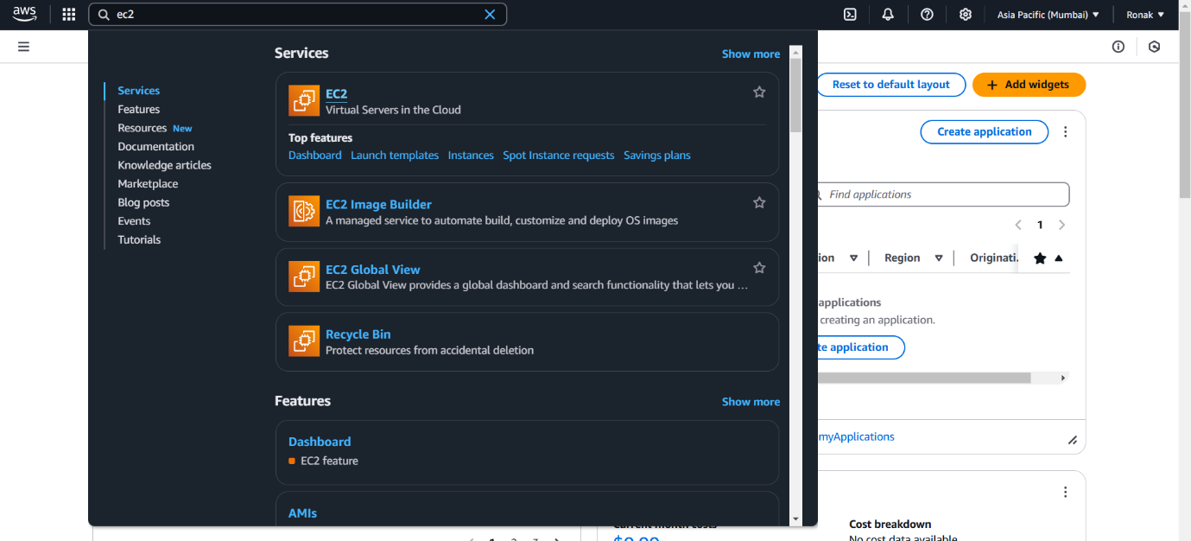
Step 2: Now, you will see various options such as Resources, Account Attributes and can explore them further.
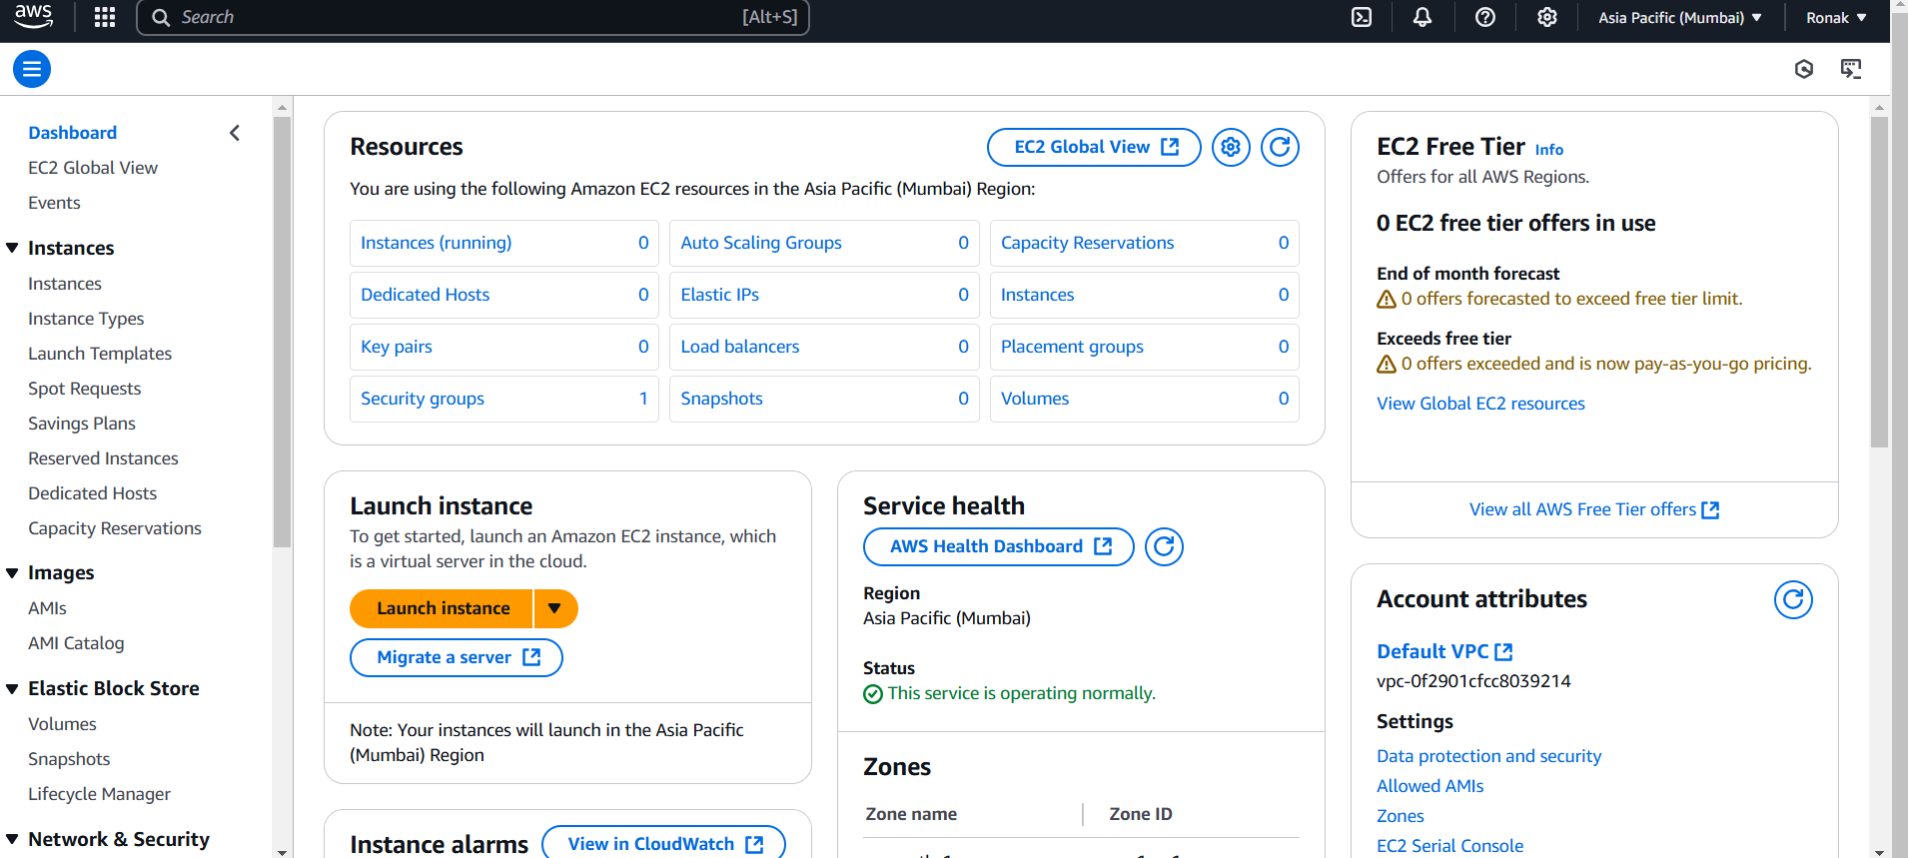
Step 3: Now, go to the Instances options present at the left side and click on Launch instance for creating a new instance.
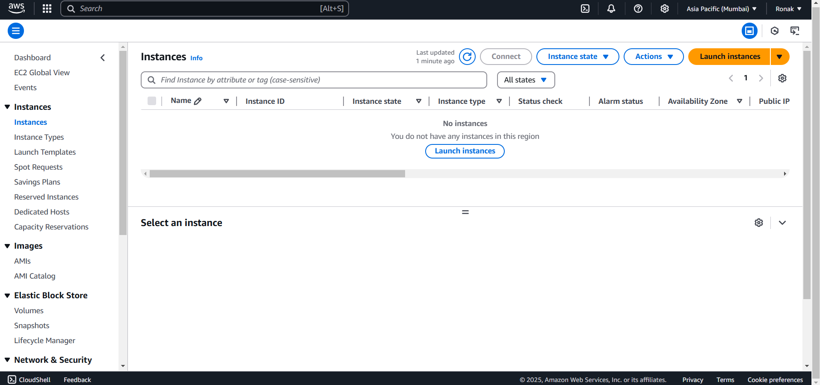
Step 4: Now, start creating Instance by first writing Name and then selecting AMI from the listed options
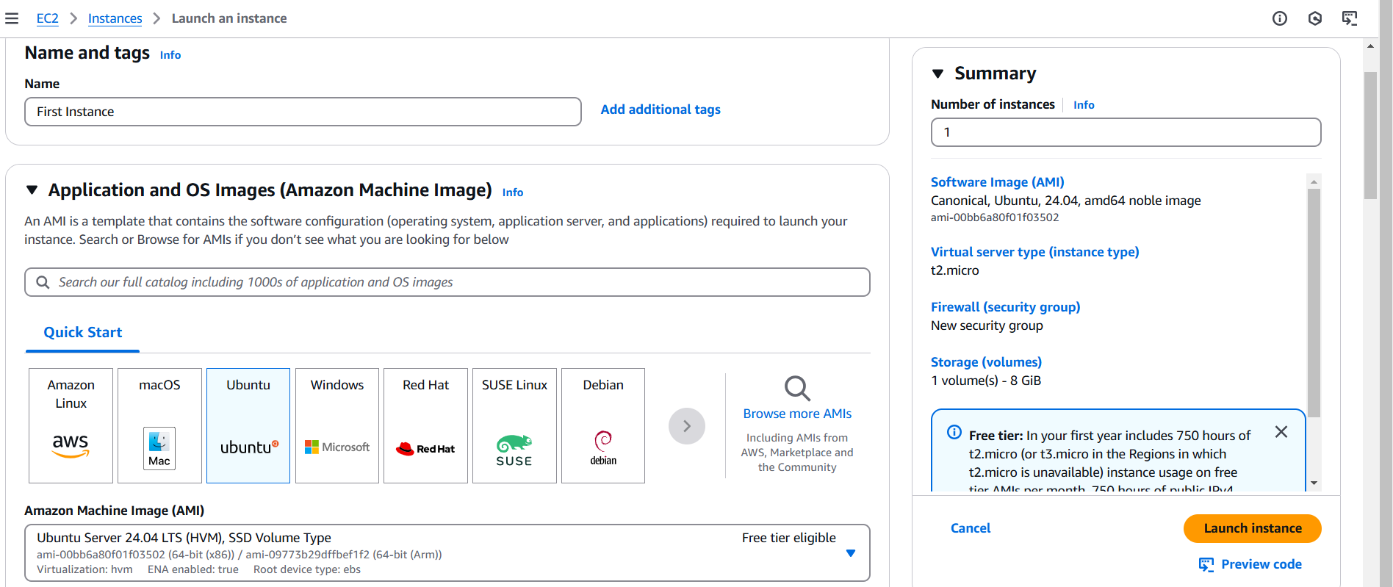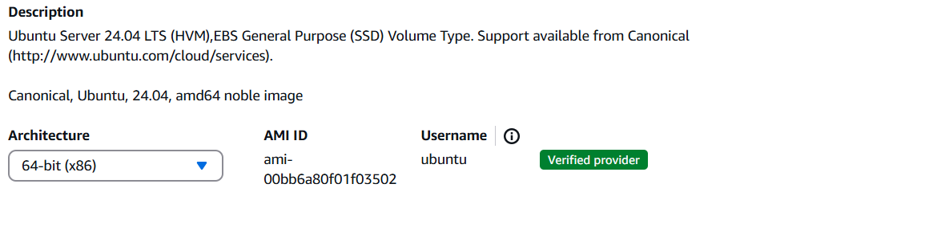
Step 5: Now, select instance type compatible with the selected AMI.
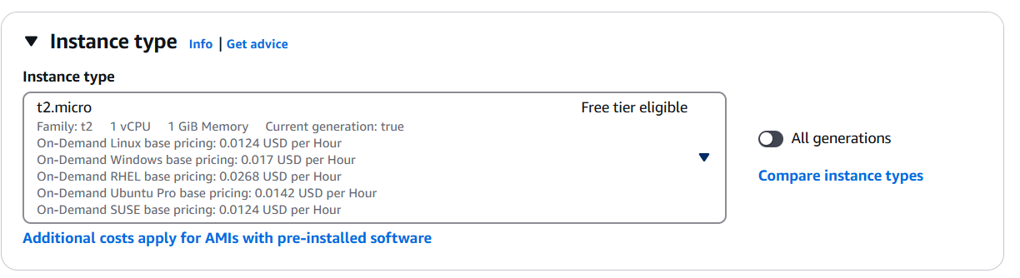
Step 6: Now, go to Key Pair and click “create new key pair” and one has to remember throughout the journey because if this key pair is lost then instance is also lost.
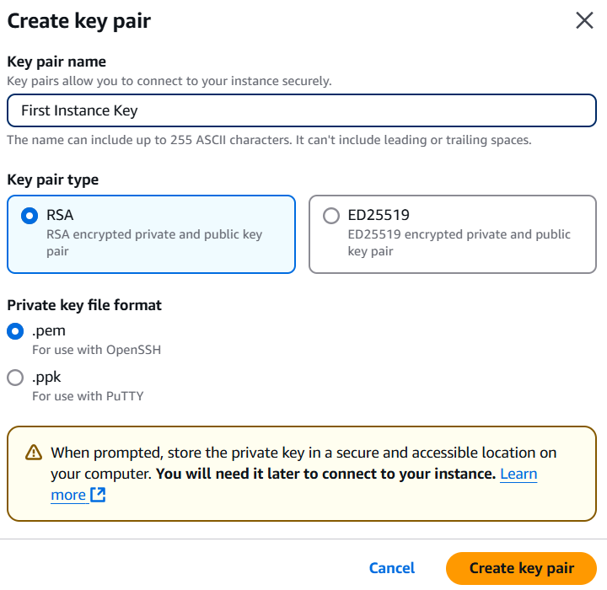
Now, the key pair will be downloaded, keep it with you.
Step 7: Now, you can select “Security Group” and “Allow SSH traffic from” in the Network section.
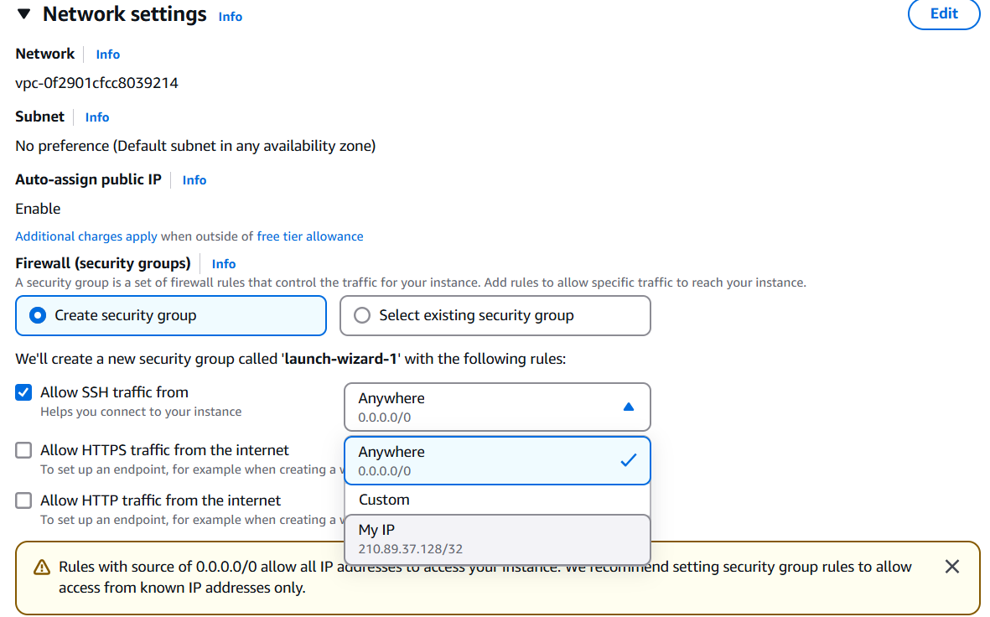
Step 8: Now, add configuration storage which needs to be 8 gb minimum.
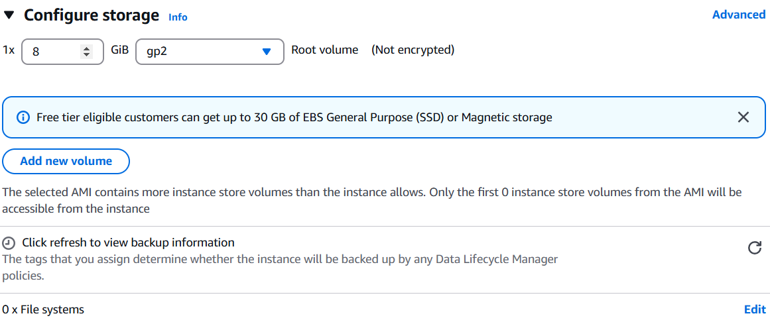
Step 9: Now, click on Launch Instance from bottom-right.
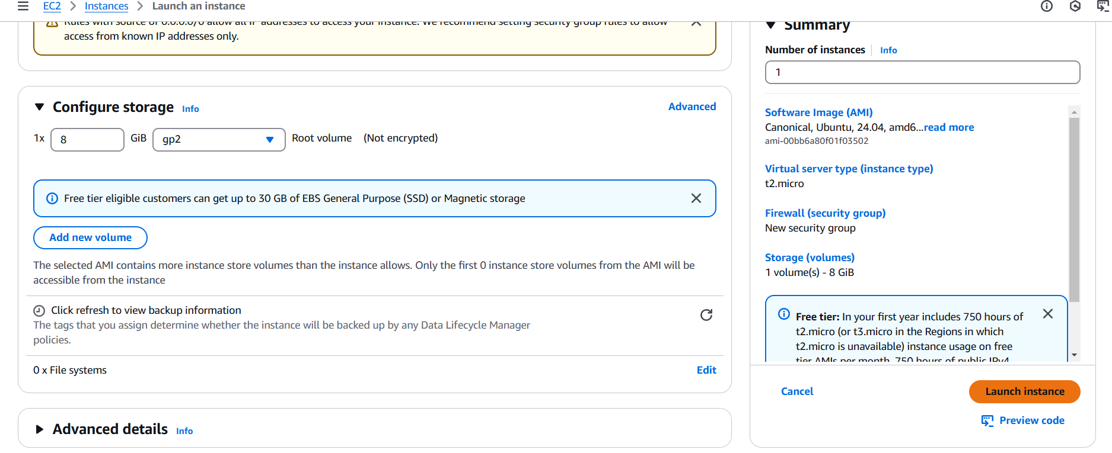
Step 10: Now, in the Instances section, you can see the instance created in running state.
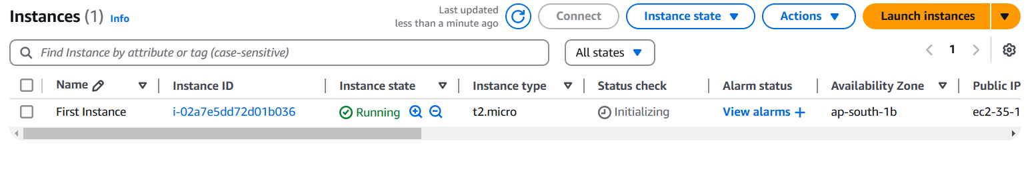
Step 11: Now, you can open the instance and explore all details of the instance such as Public IPv4 address and Instance ID.
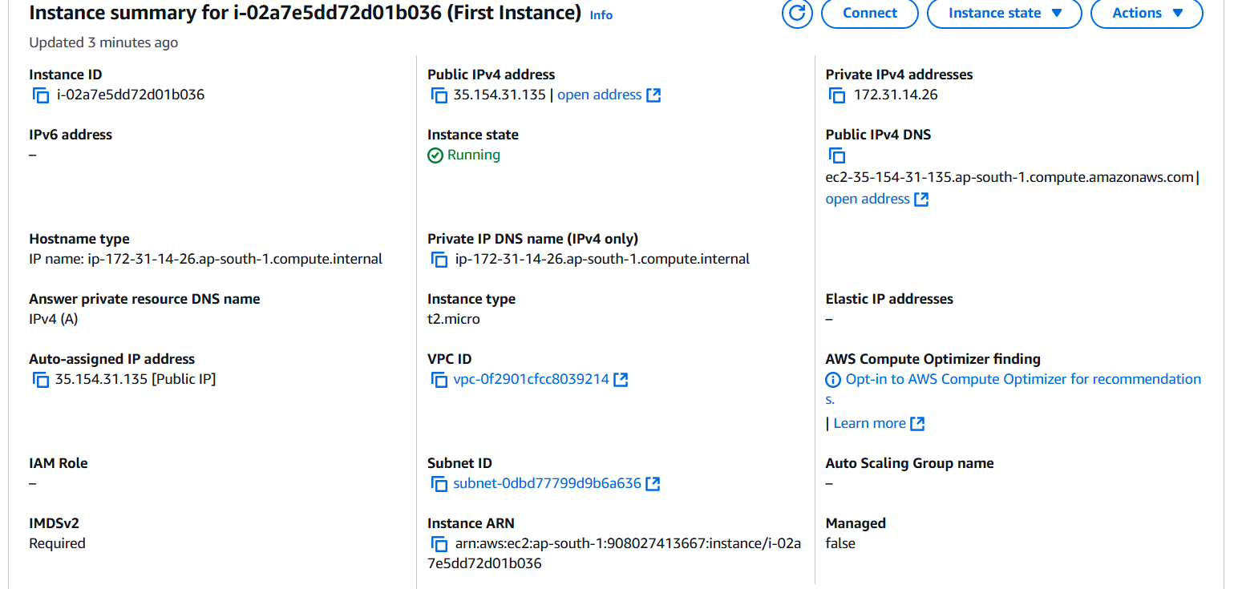
NOTE: Now, you need to convert Dynamic Auto-assigned IP address to static because Dynamic IP addresses assigned to an EC2 instance change each time the instance is stopped and restarted. However, using a static IP address, known as an Elastic IP, ensures that the instance retains the same public IP address across reboots. This consistency simplifies communication and eliminates the need to update configurations or dependencies after each restart.
Step 12: For this, you need to go to Elastic IPs under Network and Security section from left and go to Allocate Elastic IP Address.
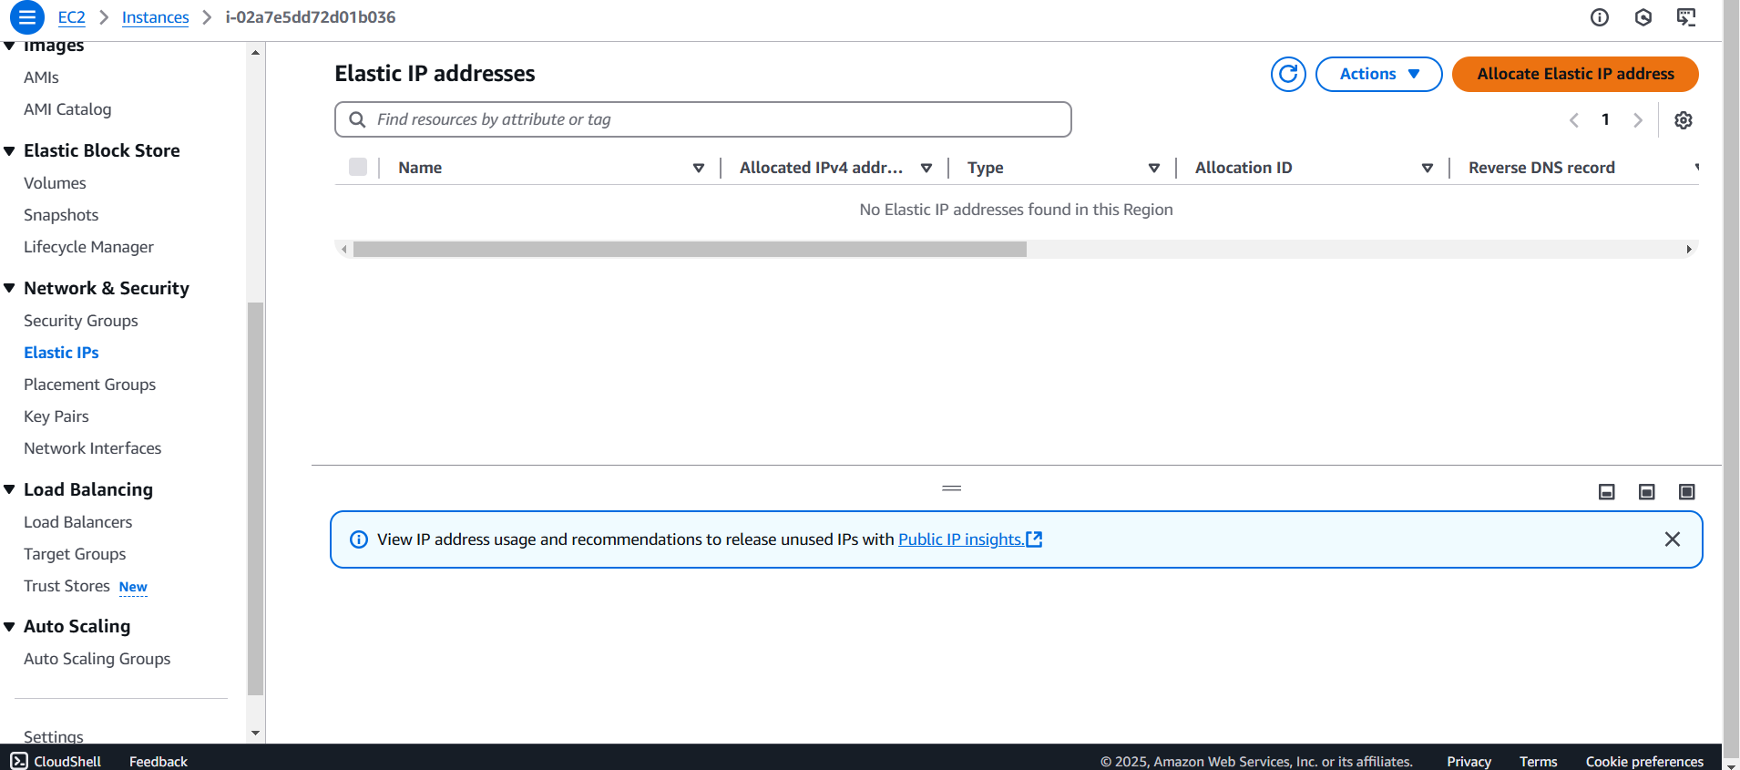
Step 13: Allocate and the allocated one will come in the list like below-
Step 14: Now, select the Elastic IP address and go to Actions and click on Associate Elastic IP address
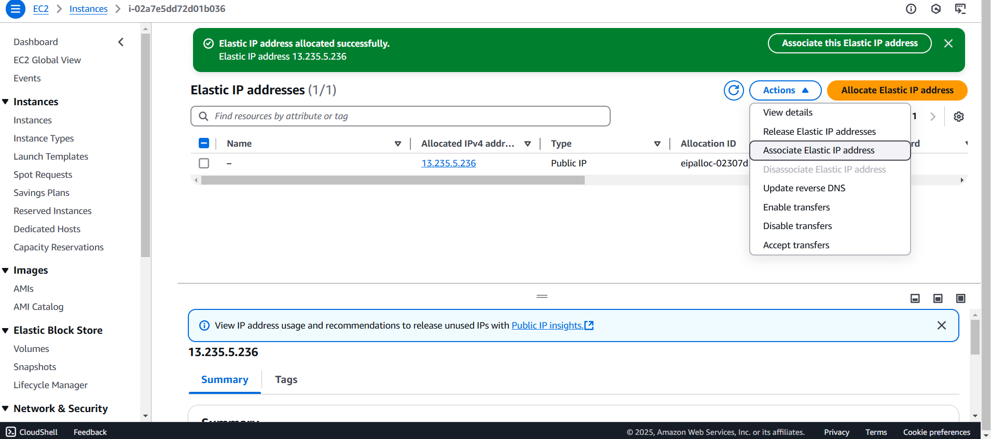
Step 15: Now, select the instance and click on Associate.
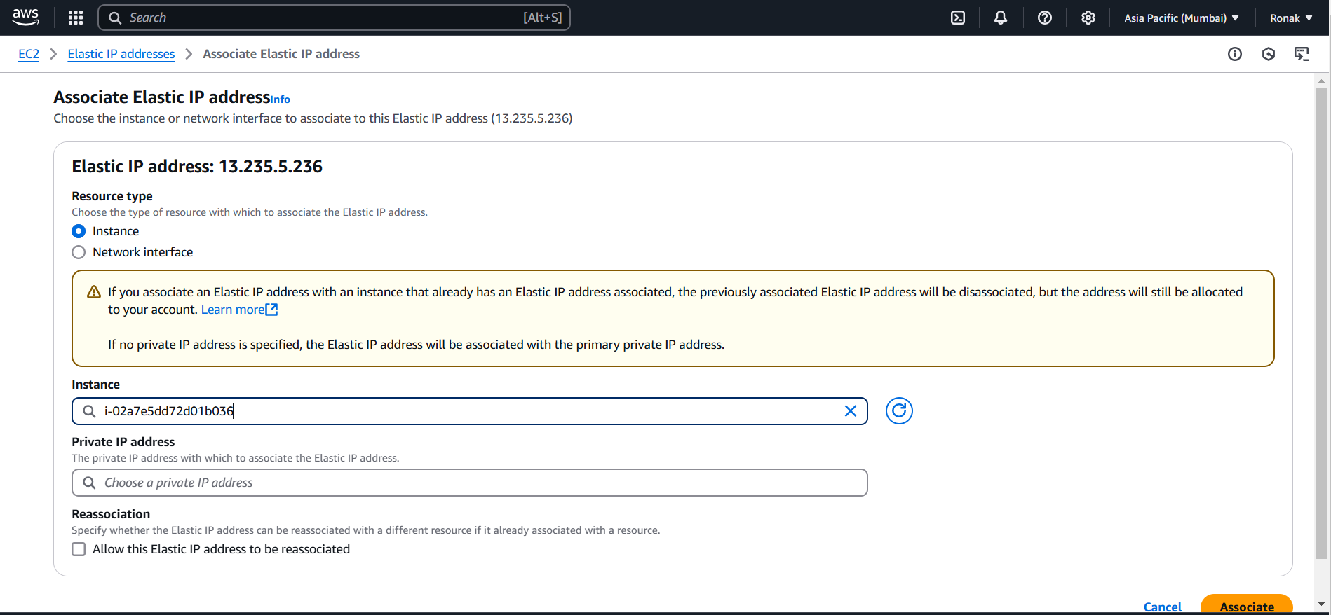
Step 16: Now, you can go again to the Instance and see Auto-assigned IP addresses from dynamic to static.
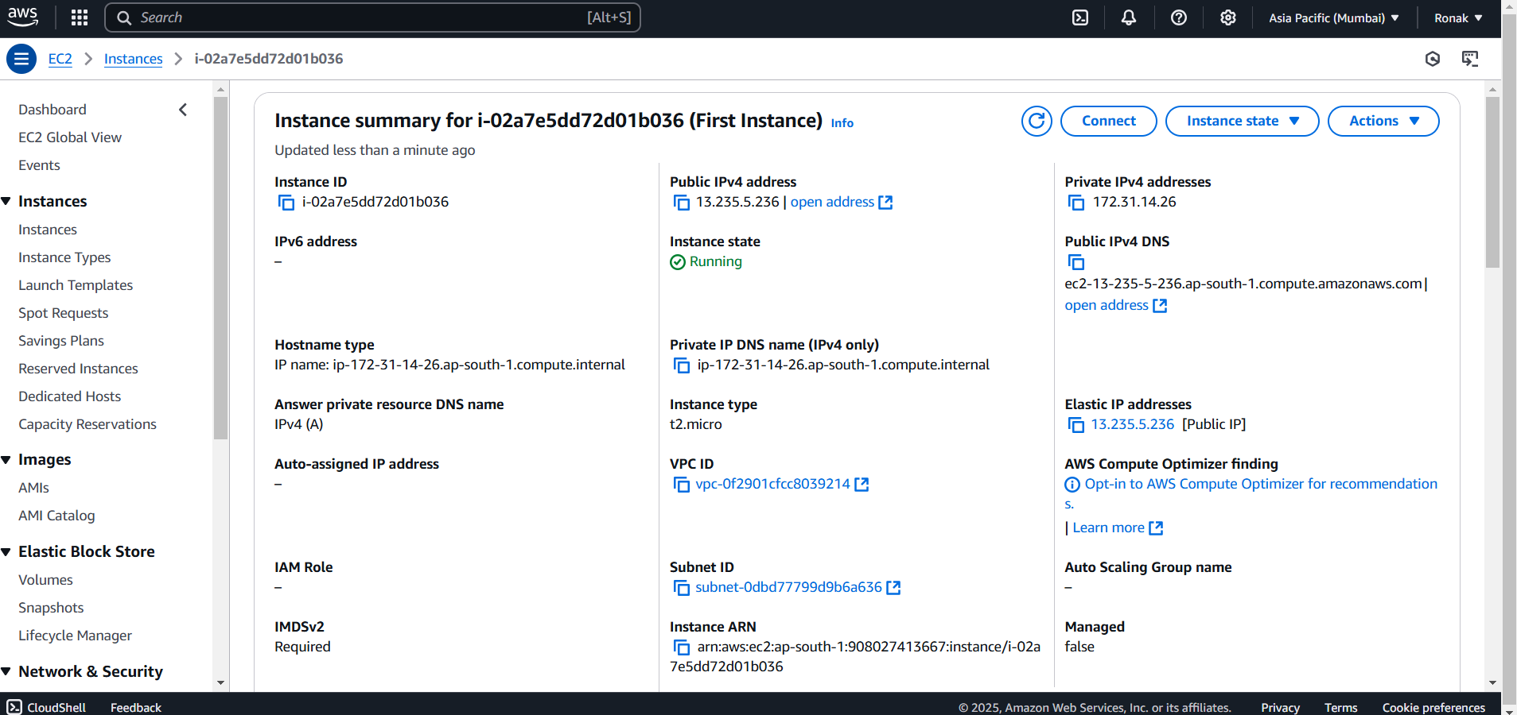
Step 17: Now, you can click on Connect and you will get 4 options to Connect to Instance.
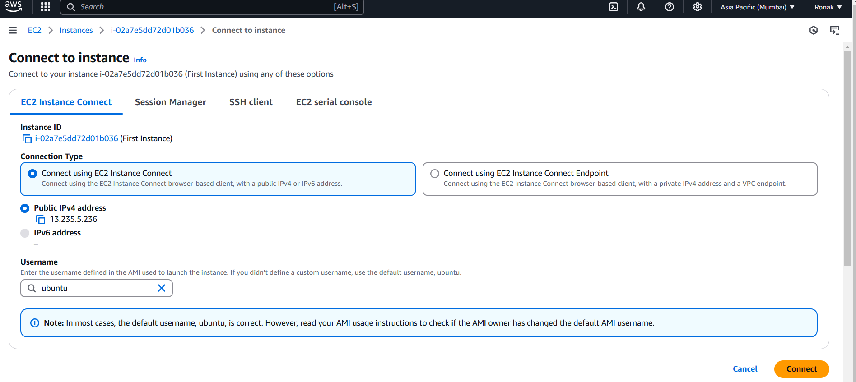
Step 18: So, this is the terminal of the virtual machine (instance) which we have created and we can write commands here, in our case it is ubuntu you can choose any in Step-4.
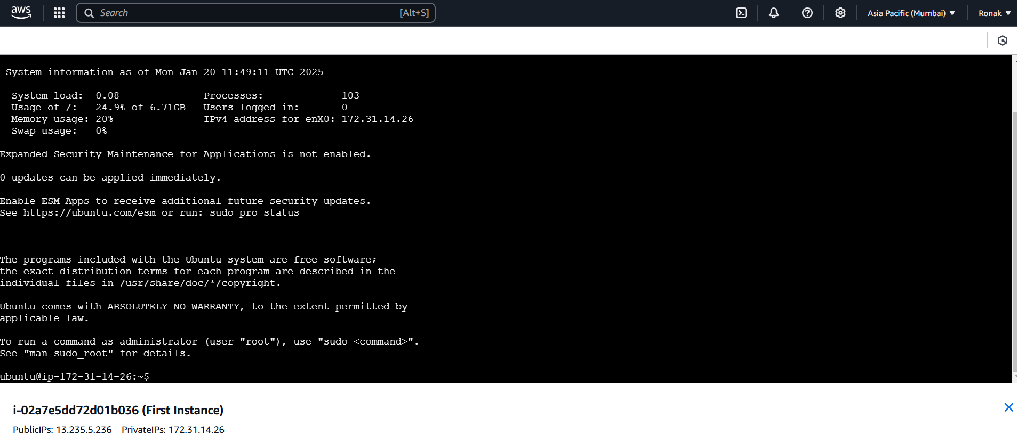
Step 19: Now, after completing your instance, always remember to stop the instance and also disassociate Elastic IP address to avoid any charges if you are not using Free Tier.
